James Kennedy

Dr. Pulimood

CSC 415

4/6/18

OSS Analysis and Design

These designs are for my new app idea, an app that can record vibration patterns and apply them to different notifications. This app will help visually impaired individuals identify the notifications they receive much more easily, while only having to use touch to do it.

Use Case Descriptions:

1. User wants to record a new pattern
   1. Primary actor - User
   2. Goal - create a new vibration pattern that can be saved and added to the list of available patterns.
   3. Preconditions - System must currently be on the recording window of the app
   4. Scenario
      1. User opens the app
      2. User navigates to the recording tab
      3. User can press or hold the vibration button on the page to experiment with patterns or practice a desired one
      4. When ready, the user presses record to begin the recording
      5. The user presses and holds the vibrate button several times to create the desired pattern and timings.
      6. Pop-up comes up and asks user to save the pattern
      7. User inputs name and saves
   5. Exceptions
      1. User decides not to save pattern (hits cancel in popup)
      2. User tries to stop recording without any vibration inputs (recording stops, no popup)
2. User wants to apply a pattern to a notification
   1. Primary Actor - User
   2. Goal - apply a vibration pattern to a certain notification or set of notifications
   3. Preconditions - System must be on the patterns list to be able to apply a vibration, and there must be at least one saved pattern to apply a vibration
   4. Scenario
      1. User opens app
      2. User navigates to the saved patterns list
      3. User selects a desired pattern
      4. Popup window displays asking which notifications to apply this too
      5. User makes a selection and then presses ok to confirm
   5. Exceptions
      1. User decides not to apply the pattern (can press cancel in the popup to stop the operation)
      2. User tries to confirm pattern without selection a notification to apply it to (app displays message to make a notification selection)

Class Diagram:

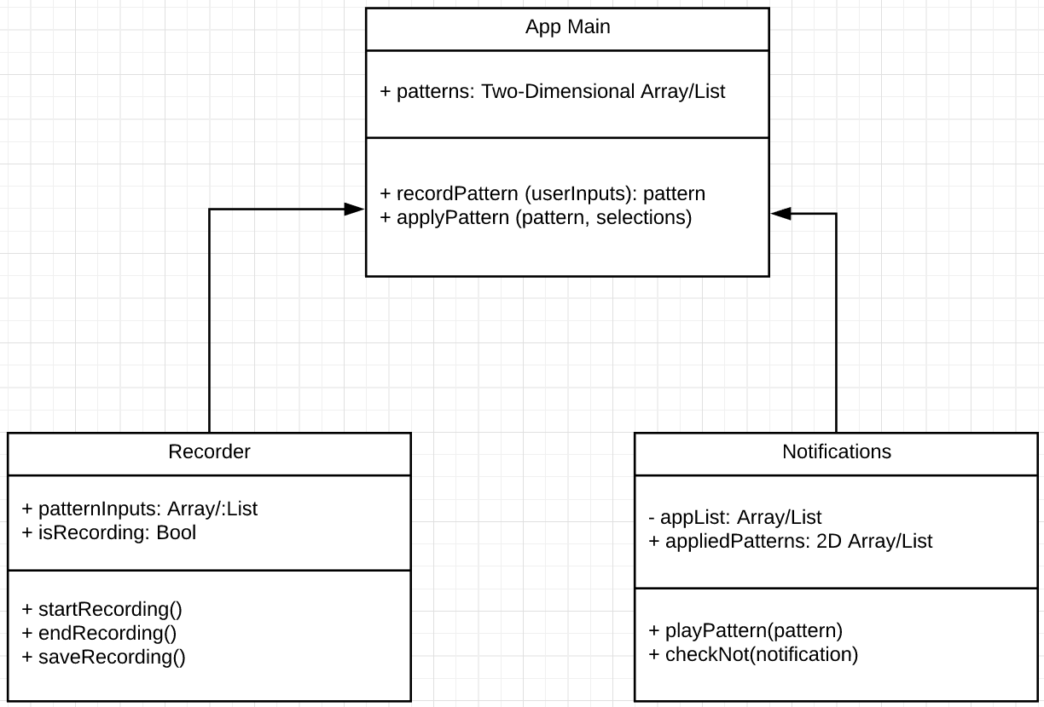

Statechart:

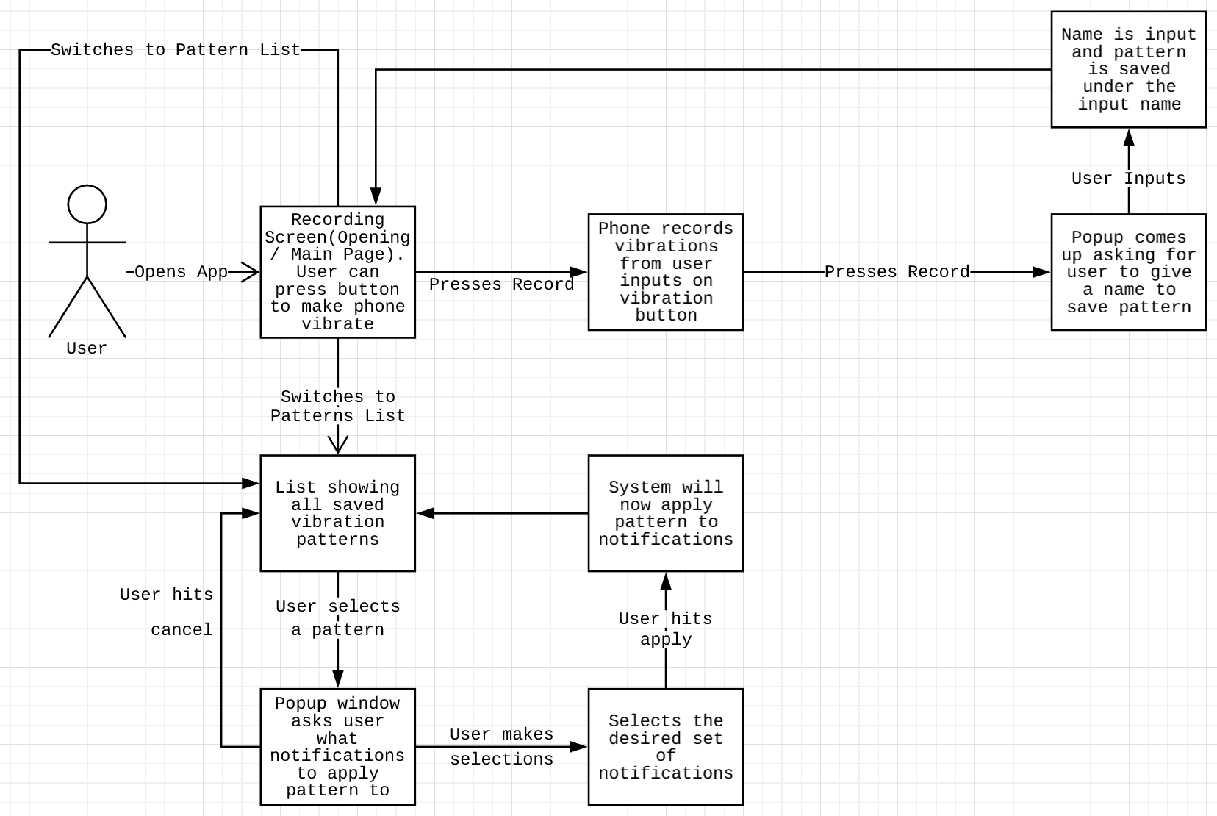

System Sequence Diagram:

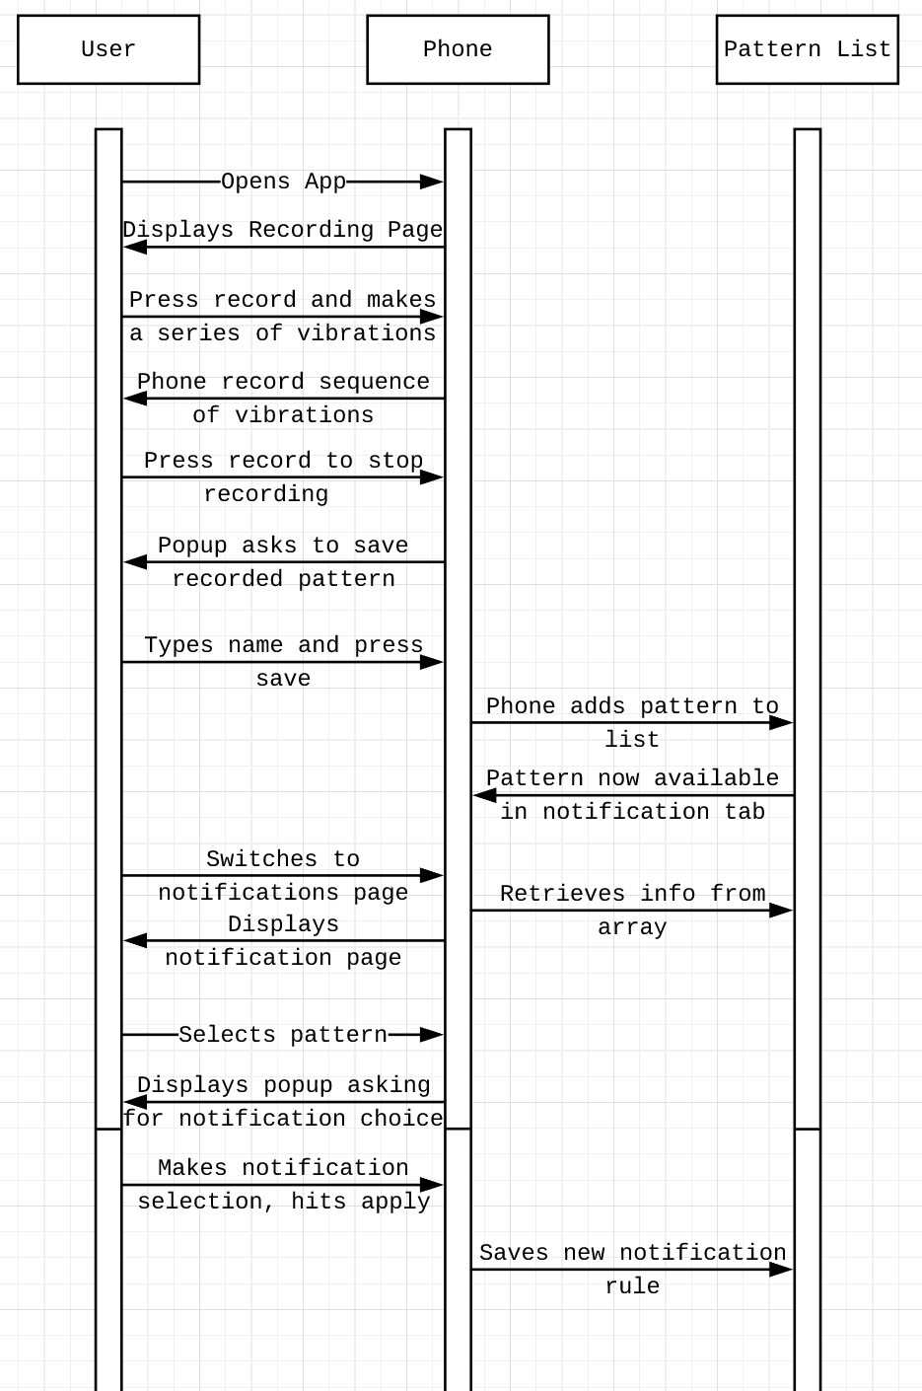

UI Concept:

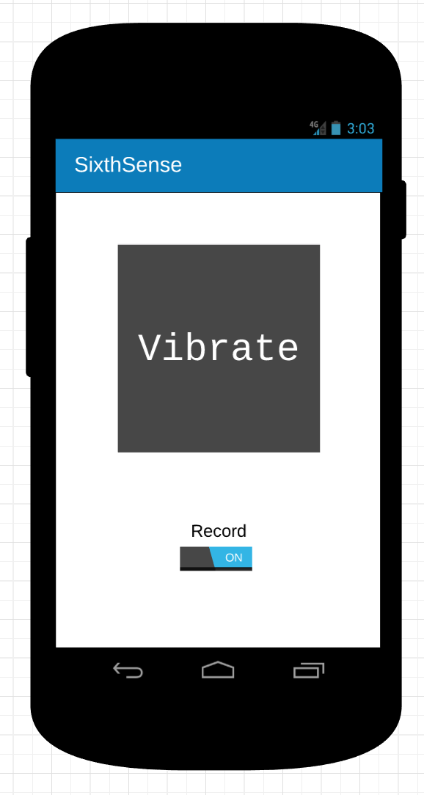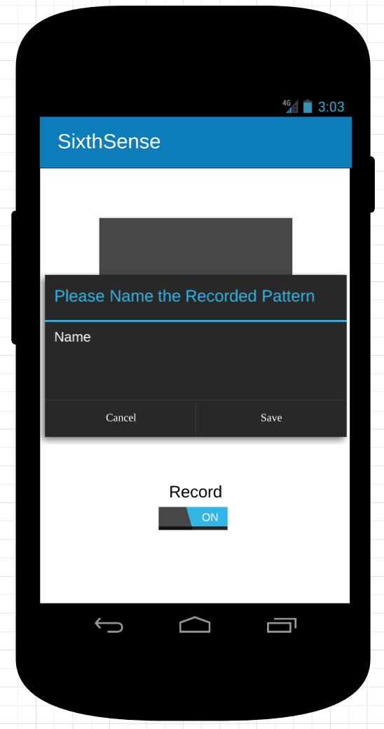

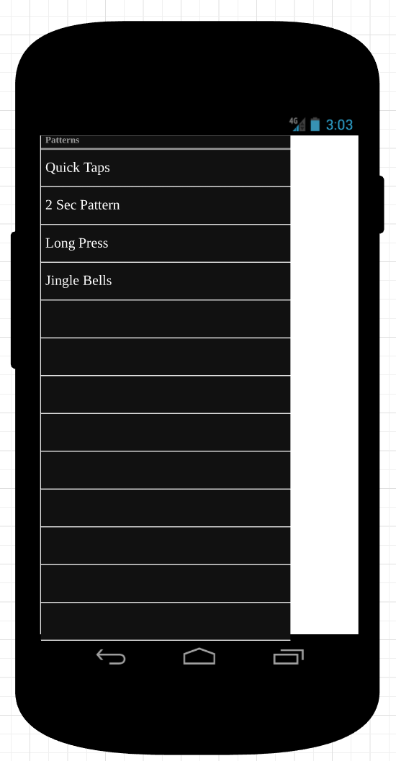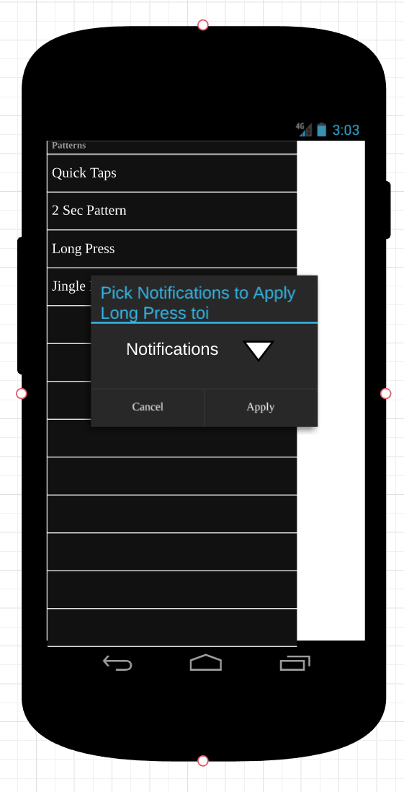

This UI abides by the 8 eight golden rules of UI design by maintaining a consistently simplistic UI design that minimizes navigation and focuses on relaying relevant information. The UI provides simple dialogs and popups to finalize actions and alert of errors.

This program uses encapsulation to organize the functionality into the three primary groups. Main/UI functionality, Pattern recording and Notification Management to help organize functions and architecture. This program maintains elegance by maintaining simplicity in design and implementation and approaches data by using arrays to organize information into well sorted groups.

Test Cases:

|  |  |  |  |
| --- | --- | --- | --- |
| **Functionality Tested** | **Inputs** | **Expected output** |  |
| Recording Patterns | Given sequence of vibrations  After toggling on recording | System should save and be able to playback pattern |  |
| Apply patterns to notifications | Generate various notifications | Proper vibrations with corresponding notifications |  |
| Notification tab displays proper list of saved patterns | Generated pattern list | Notification page displays complete and accurate list of patterns |  |
| Press button to make vibration | User presses large button on recording page | Phone vibrates while button is held |  |
| Save recorded pattern | Toggle off recording | Window asking for name to save under |  |